[](http://www.suafermata.com)

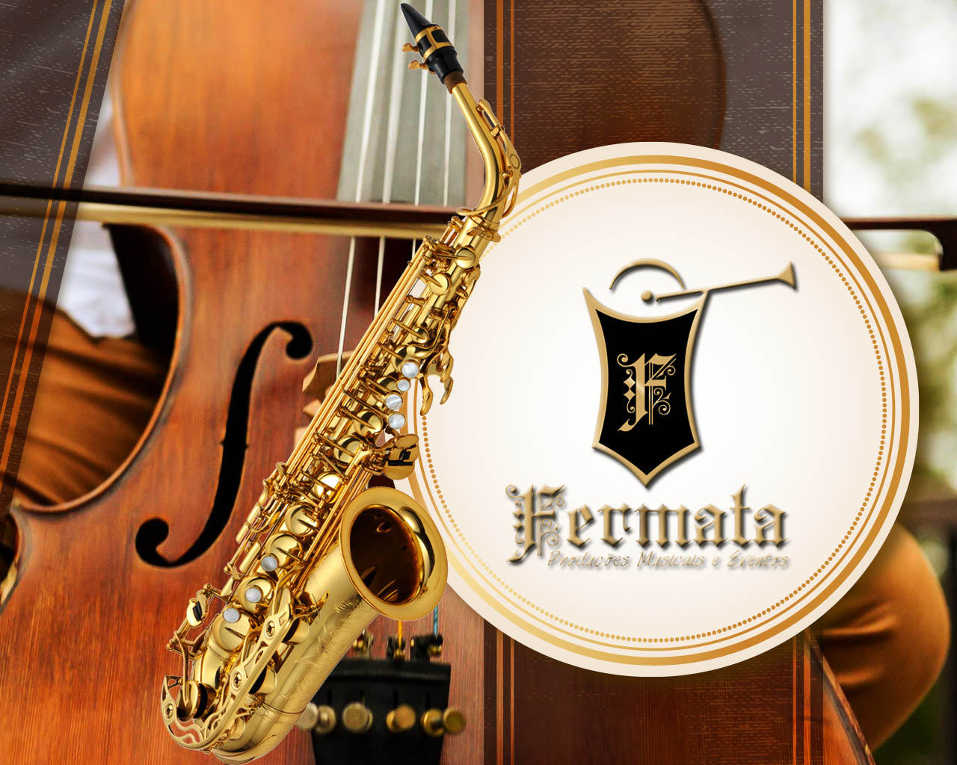

**Os 15 hits atuais para festa de casamento.**

**Batom de Cereja -** [**https://www.youtube.com/watch?v=3vYeQLJ2as4**](https://www.youtube.com/watch?v=3vYeQLJ2as4)

**Foi Pá Pum -** [**https://www.youtube.com/watch?v=G8xc80bWKzI**](https://www.youtube.com/watch?v=G8xc80bWKzI)

**Quero ver é me esquecer:** [**https://www.youtube.com/watch?v=saViw05xftI**](https://www.youtube.com/watch?v=saViw05xftI)

**Esquema preferido -** [**https://www.youtube.com/watch?v=TCLGN6m6AMI**](https://www.youtube.com/watch?v=TCLGN6m6AMI)

**Fala comigo -** [**https://www.youtube.com/watch?v=dUa6latApUA**](https://www.youtube.com/watch?v=dUa6latApUA)

**Só não divulga:** [**https://www.youtube.com/watch?v=qIMlrNuPvsw**](https://www.youtube.com/watch?v=qIMlrNuPvsw)

**Amor da despedida:** [**https://www.youtube.com/watch?v=paKByf8X-gQ**](https://www.youtube.com/watch?v=paKByf8X-gQ)

**Hackearam-me:** [**https://www.youtube.com/watch?v=2M4PJJoHNQ4**](https://www.youtube.com/watch?v=2M4PJJoHNQ4)

**Já sabe:** [**https://www.youtube.com/watch?v=386UxunNURg**](https://www.youtube.com/watch?v=386UxunNURg)

**Carro do ovo:** [**https://www.youtube.com/watch?v=m-gBWvo5NHI**](https://www.youtube.com/watch?v=m-gBWvo5NHI)

**Alexa:** [**https://www.youtube.com/watch?v=Mc1SZLULE1o**](https://www.youtube.com/watch?v=Mc1SZLULE1o)

**Quem traiu levou.** [**https://www.youtube.com/watch?v=FmcNr5Z3wWQ**](https://www.youtube.com/watch?v=FmcNr5Z3wWQ)

**Dois lados -** [**https://www.youtube.com/watch?v=ZlKbVfL2cUk**](https://www.youtube.com/watch?v=ZlKbVfL2cUk)

**Já que me ensinou a Beber** [**https://www.youtube.com/watch?v=TkUeVvbGzfo**](https://www.youtube.com/watch?v=TkUeVvbGzfo)

**Cheiro de amor no ar - Zeca bota bom** [**https://www.youtube.com/watch?v=7dKdvqmR8FA**](https://www.youtube.com/watch?v=7dKdvqmR8FA)

**Clique nos links e ouças as músicas**